LAB:06
Kafka Integration with C#:
- Kafka Folder
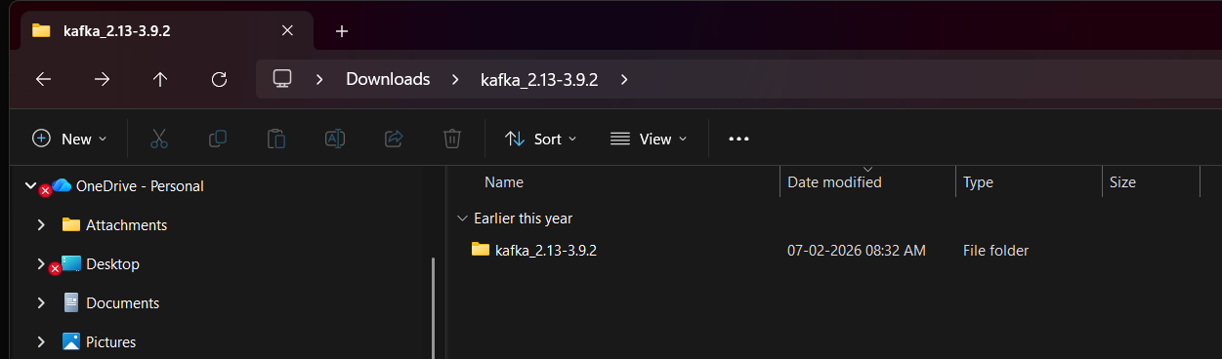

- ZooKeeper Running
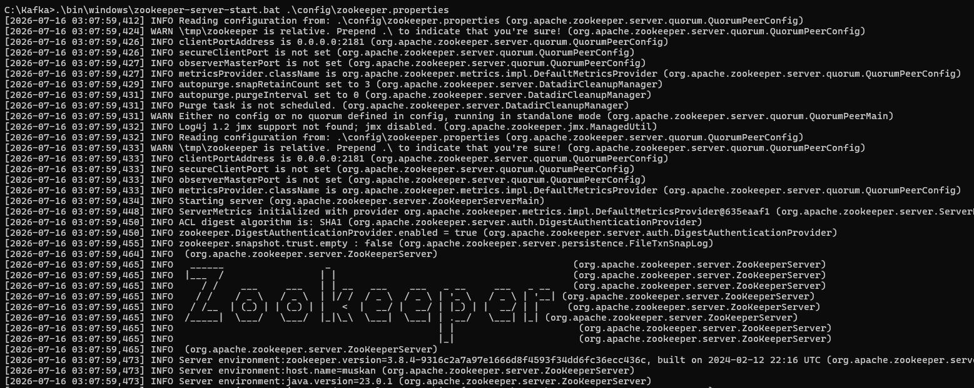

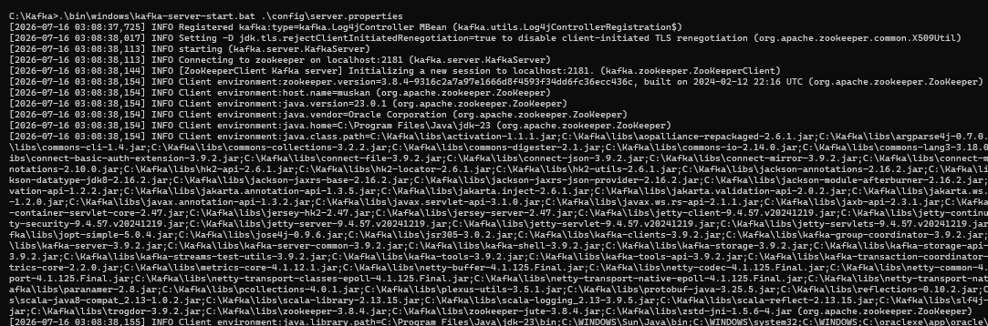
- Kafka Server Running

- Kafka Topic Created
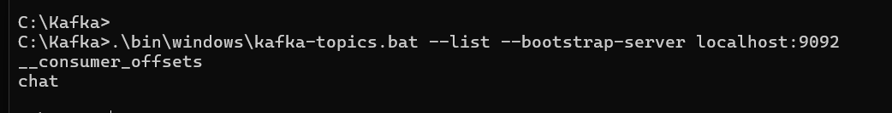

- Visual Studio Project
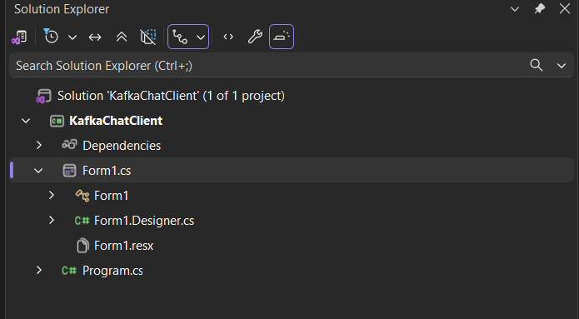

- NuGet Package
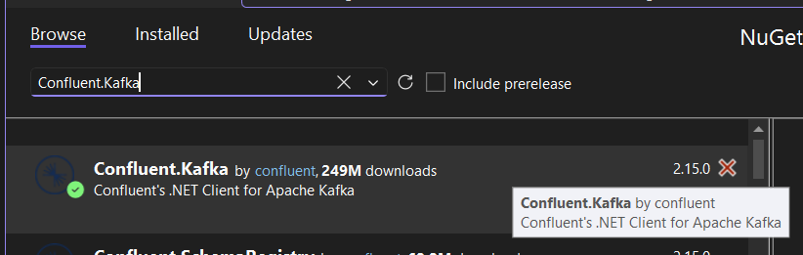

- Producer
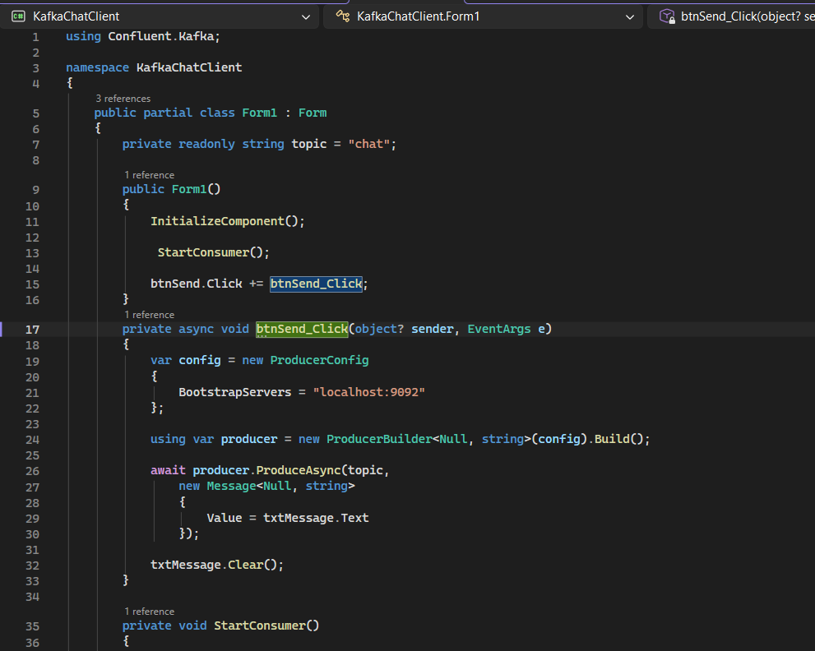

- Consumer
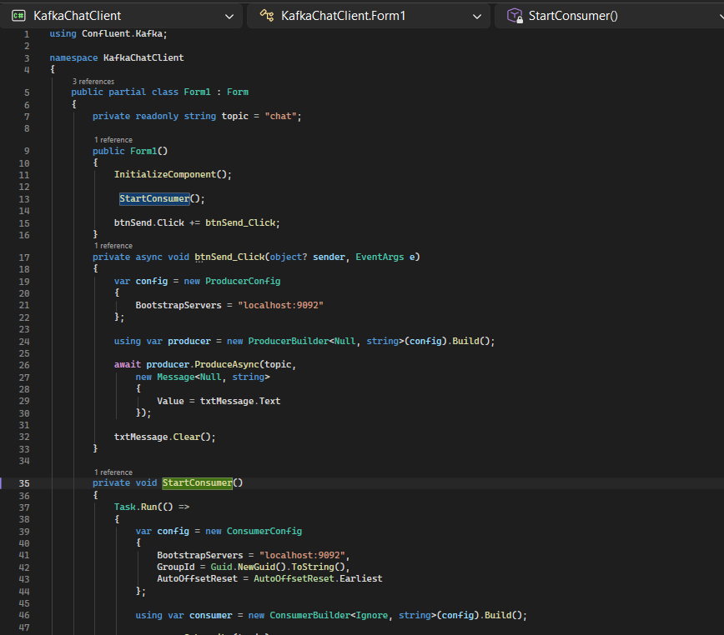

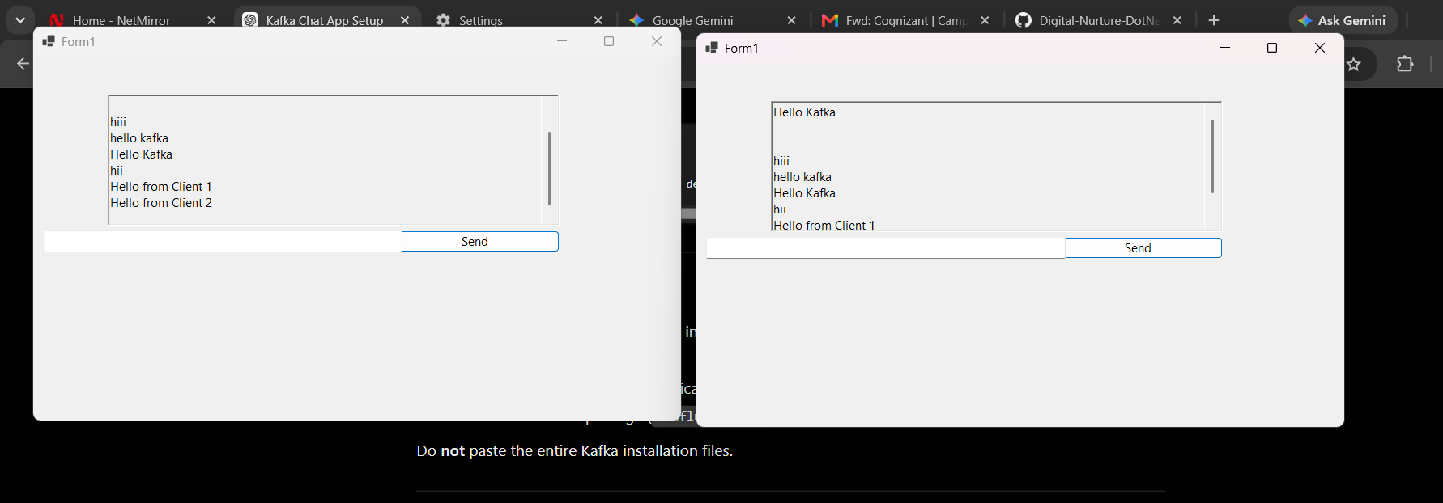
9.

Result:

The Chat Application was successfully developed using Apache Kafka. Messages were sent and received successfully between multiple client applications using Kafka as the streaming platform.

